امارت اسلامی افغانستان
وزارت تحصیلات عالی
ریاست موسسات خصوصی تحصیلات عالی
پوهنتون رڼا
ریاست پوهنحی کمپیوتر ساینس
آمریت دیپارتمنت انجنیری نرم افزار

Islamic Emirate of Afghanistan
Ministry of Higher Education
Directorate of Private Higher Education
RANA University
Directorate of Computer Science Faculty
Department of Software Engineering

MONOGRAPH PROPOSAL
ON

Darman Pharmacy Management System
سیستم مدیریت دواخانه درمان

BY
Ahmad Shoaib
22-RE200-214
In partial fulfillment of the requirements for the award of the degree of
BACHELOR OF SOFTWARE ENGINEERING
BSE
TO
RANA University
Baraki Square, Kabul–Afghanistan

Islamic Emirate of Afghanistan
Ministry of Higher Education
Directorate of Private Higher Education
RANA University
Directorate of Computer Science Faculty
Department of Software Engineering

د افغانستان اسلامی امارت
د لوړو زده کړو وزارت
د لوړو زده کړو د خصوصي پوهنتونو ریاست
رڼا پوهنتون
د کمپیوټر ساینس پوهنځي ریاست
د سافت ویرانجنیرنګ ډیپارتمینت

MONOGRAPH PROPOSAL
ON
Your Project Title
In partial fulfillment of the requirements for the award of the degree of
)BSE(
TO
RANA University
TO BE PREPARED BY:
Name:
Father’s Name:
Registration No:
Phone No:
E-Mail:
Batch: 202 to 202
SUPERVISED BY:
Name: Sajjad Sulimankhail
Designation: Head of IT department & Lecturer
Qualification: Bachelor of Computer Science
ID No: RU-02-204
Phone No: +93 744 86 82 52
E-mail: head.bit@ru.edu.af
Signature:
Date:
Signature:
Date:

Table of Contents
Executive Summary
1. Introduction
2. Existing System
3. Proposed System
4. Logical Design
5. Physical Design
6. Tools and Technologies
7. Project Time and Cost Estimation
8. Project Timeline
9. Risk Assessment and Trust Signals
10. Conclusion
11. References

Executive Summary

Darman Pharmacy Management System is a secure, single-branch web application designed to improve the daily operation of a community pharmacy. The project addresses recurring operational problems such as inaccurate stock records, weak expiry monitoring, slow sales processing, fragmented supplier information, and limited reporting. It replaces paper-based or spreadsheet-based work with a unified system that is suitable for pharmacy owners and staff with limited technical experience.
The proposed solution covers medicine and category management, batch-based inventory, low-stock and expiry alerts, point-of-sale processing, supplier management, purchase orders, role-based access, operational reports, and CSV or PDF exports. Sales deduct inventory atomically using First Expire, First Out allocation. Purchase receiving creates inventory batches and stock adjustment records in one protected transaction. Administrative, pharmacist, and cashier roles provide clear separation of responsibility.
The project is implemented with Next.js, TypeScript, Supabase PostgreSQL and Auth, Tailwind CSS, shadcn/ui, TanStack Query, React Hook Form, Zod, Recharts, and jsPDF. Row Level Security and database functions protect sensitive workflows. The release candidate has passed staging tests covering permissions, concurrent sales, rollback behavior, purchase receiving, reporting, exports, responsive layouts, and security headers. Production deployment remains dependent on applying the reviewed migrations, configuring production services, assigning backup ownership, and completing production smoke tests.
The work is planned as a twelve-week academic software project. Development labor is treated as the student's academic contribution, while the estimated direct project cost is USD 230 for connectivity, electricity, a domain, printing, testing, and contingency. The result is a practical monograph project that demonstrates requirements analysis, database design, secure full-stack development, quality assurance, and deployment planning.

1. Introduction

1.1 Background
Community pharmacies manage many fast-moving products with different batch numbers, prices, suppliers, and expiry dates. Daily decisions depend on knowing what is available, what is safe to sell, what must be reordered, and which stock should be used first. When these records are maintained manually, a small recording error can affect purchasing, sales, reporting, and customer service.
A pharmacy management system should therefore provide more than a medicine list. It should connect purchasing, batch inventory, sales, alerts, and reporting while preserving a clear record of each stock movement. It must also be simple enough for a cashier or pharmacist to learn quickly and secure enough to prevent unauthorized changes.

1.2 Project Aim
The aim of this project is to design, implement, test, and prepare for deployment a production-quality, single-branch pharmacy management system that supports core operational workflows without introducing clinical, insurance, or enterprise accounting functions.

1.3 Objectives
- Create a searchable medicine catalog with categories, barcodes, pricing, supplier references, reorder levels, and active or inactive status.
- Track physical inventory by batch number, quantity, received date, cost, selling price, and expiry date.
- Provide low-stock and expiry warnings that support timely purchasing and stock handling.
- Implement a fast cashier-oriented point of sale with barcode scanning, discounts, receipts, and protected stock deduction.
- Manage suppliers and purchase orders from draft creation through ordered, delivered, or cancelled states.
- Provide role-based access for Admin, Pharmacist, and Cashier users.
- Produce basic operational reports with filters and CSV or PDF exports.
- Protect data with validation, Row Level Security, transactional database functions, and auditable inventory adjustments.
- Deliver deployment, testing, maintenance, and beginner user documentation.

2. Existing System

2.1 Current Operating Approach
The existing environment is assumed to use paper records, informal stock counting, spreadsheets, or separate applications for sales and purchasing. Such approaches can work for a very small inventory, but they become difficult to control as the number of products, batches, suppliers, and transactions increases.
Data is often re-entered into several records. A purchase may be recorded in a notebook, stock may be changed in a spreadsheet, and sales totals may be calculated separately. Because these records are not connected, managers cannot easily confirm whether a figure is complete or current.

2.2 Identified Problems
Area | Existing Limitation
Stock accuracy | Manual deductions and delayed updates can produce incorrect availability and purchasing decisions.
Expiry control | Expiry dates may be checked visually instead of through systematic, configurable warnings.
Batch traceability | The batch sold or received may not be connected to the related transaction.
Sales speed | Manual medicine lookup, calculations, and receipt preparation slow down checkout.
Supplier records | Contact information and order history can be scattered across notebooks or files.
Reporting | Sales, stock value, expiry exposure, and purchase totals require repeated manual calculations.
Access control | Shared spreadsheets or notebooks provide little separation between staff responsibilities.
Auditability | It may be unclear who changed stock, when it changed, and which workflow caused the change.
Data recovery | Paper can be lost and local files may not have a defined backup or recovery owner.

3. Proposed System

Darman is a responsive browser-based management system designed for a single pharmacy branch. It provides a clear and structured digital workspace where daily pharmacy operations can be managed through focused, role-aware workflows. The system is built around the practical needs of a pharmacy environment, including medicines, sales, suppliers, purchases, reports, settings, and dashboard analytics. Each area of the application is organized so users can quickly find the tools they need without unnecessary complexity or distraction.
The navigation is role-aware, meaning each user only sees and accesses the sections that are relevant to their responsibilities. This helps protect sensitive operations, reduces confusion, and keeps the interface focused for each type of user. For example, staff members can work with the parts of the system required for their daily tasks, while higher-level users can access broader management, reporting, and configuration features.
The interface is designed to be simple, responsive, and easy to use across different screen sizes. It uses clear forms for entering and updating information, searchable lists for quickly finding records, and confirmation dialogs for actions that require extra attention. Empty states guide users when no data is available, loading feedback shows when the system is processing a request, and actionable error messages explain what went wrong and what the user can do next. These interface patterns make the system more reliable, understandable, and practical for real pharmacy usage.
The database is the authoritative source for all protected business operations. Instead of trusting the browser to make important decisions, Darman uses PostgreSQL to validate and control critical actions. When the browser requests a sale or purchase operation, the database checks the user's role, verifies the current records, and ensures that the requested action is allowed. It also locks affected data where necessary to prevent conflicts, especially in operations that involve stock quantities, financial totals, or related transaction records.
PostgreSQL calculates trusted values inside the database, such as sale totals, purchase totals, stock adjustments, and other sensitive business data. This prevents users or browser-side code from changing important values incorrectly. All related changes are committed together as one complete operation. If one part of the process fails, the entire operation is rejected instead of leaving incomplete or inconsistent records.
This approach makes Darman more dependable, secure, and suitable for real pharmacy workflows. The browser provides a clean user experience, while the database enforces business rules, protects data integrity, and ensures that sales, purchases, inventory changes, and reports are based on accurate and trusted information.

4. Logical Design

4.1 Logical Architecture
The logical design describes what information enters and leaves the system, which processes transform it, and how the principal business entities relate. It is independent of detailed hosting or programming decisions.
External actors include Admin, Pharmacist, Cashier, Supplier, Supabase Auth, and a business reviewer. Major processes cover authentication, catalog and inventory management, sales, purchasing, reporting, and administration. Data stores represent users, catalog records, batches, sales, purchases, adjustments, and settings.

4.2 Core Data Rules
- A medicine can have many inventory batches, while each batch belongs to one medicine.
- A sale contains one or more sale items, and each sale item identifies the allocated inventory batch.
- A supplier can have many purchase orders, and each purchase order contains one or more purchase items.
- Receiving an order creates or updates inventory batches and records inventory adjustments.
- Expired stock is retained for traceability but excluded from saleable quantity.
- Users receive one operational role through their profile.

DFD Diagram
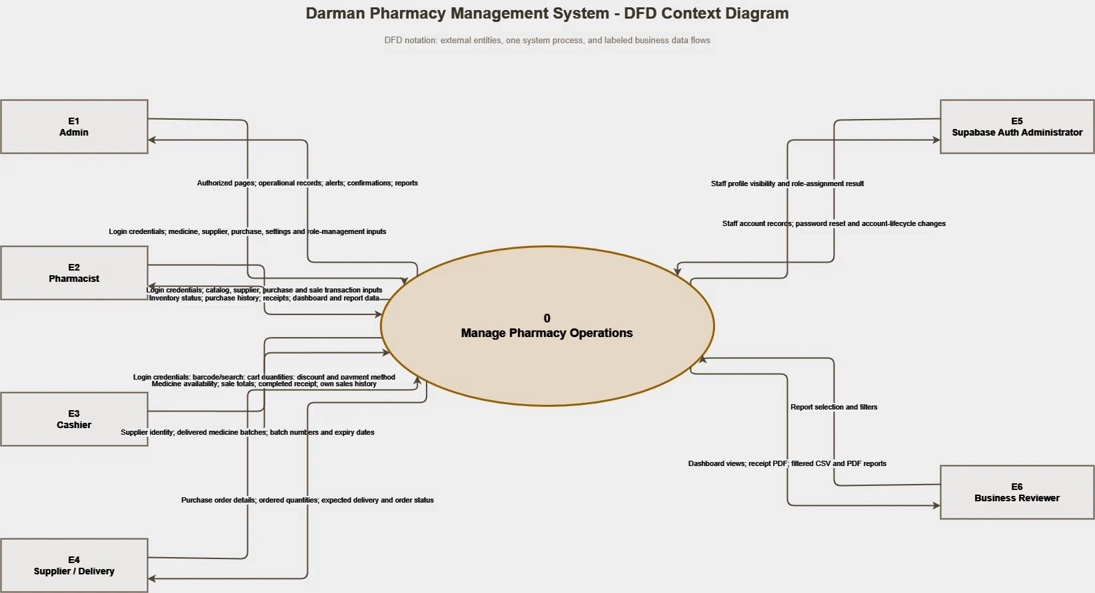
Figure 1. Context diagram showing the system boundary and its external actors.

Level 1 Data Flow Diagram
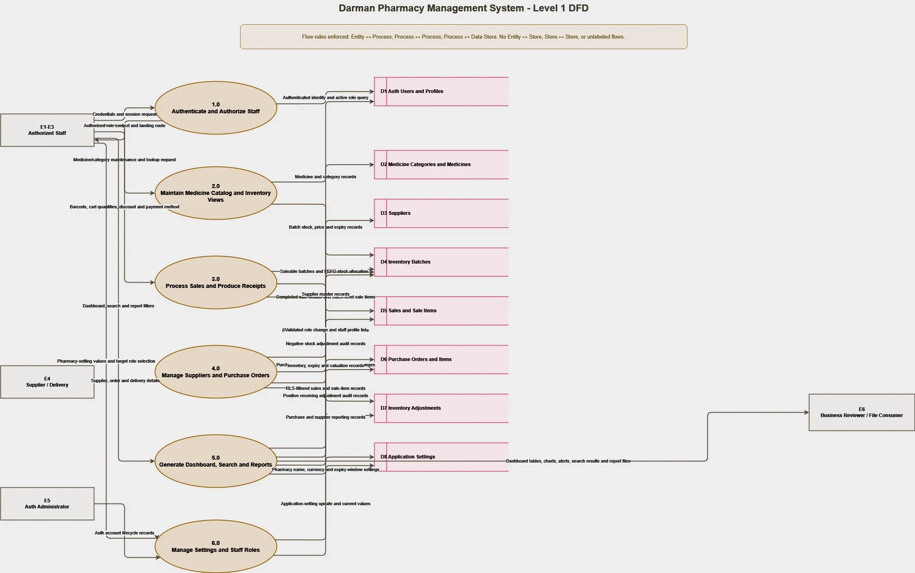
Figure 2. Level 1 DFD showing authentication, catalog, inventory, sales, purchasing, reporting, and administration processes.

Conceptual Entity Relationship Model
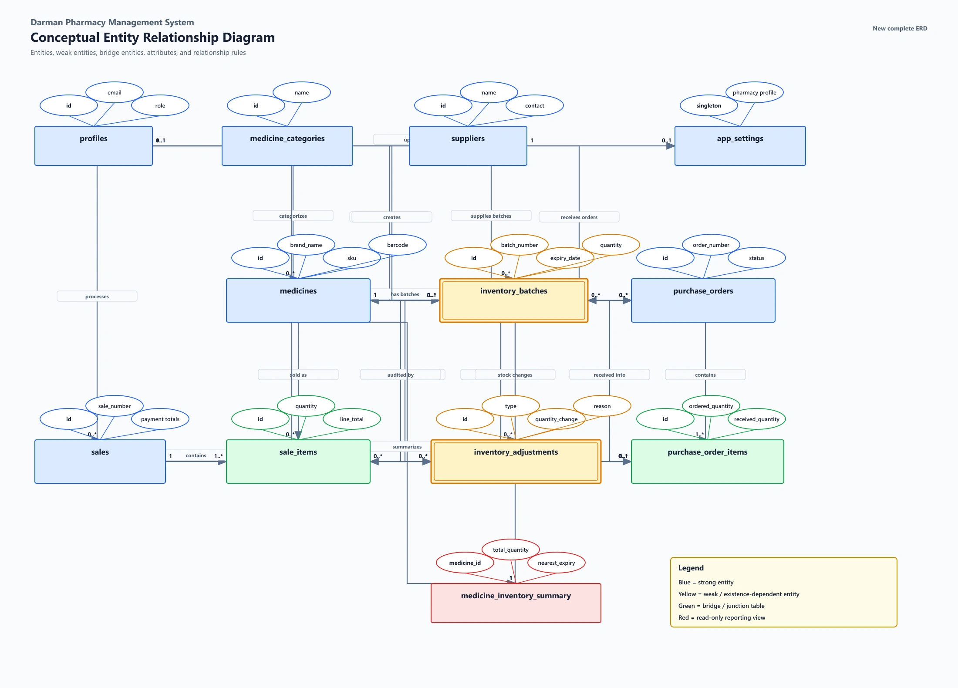
Figure 6. Conceptual ER model of staff, medicines, suppliers, inventory, sales, purchases, settings, and adjustments.

5. Physical Design

5.1 Application Architecture
The application uses the Next.js App Router for server-rendered routes, protected navigation, and client-side interactive modules. Browser components use TanStack Query for server-state caching and mutations. React Hook Form and Zod provide controlled input handling and validation.
Supabase provides PostgreSQL, email-and-password authentication, and browser-accessible APIs. Separate server and browser clients preserve the correct session context. Public Supabase keys are allowed in the browser, while RLS is the database security boundary. No service-role key is exposed to the client.
Vercel hosts the Next.js application. Supabase hosts authentication and relational data. Production configuration requires the Supabase URL and one publishable or legacy anonymous key, plus the final application URL in Supabase Auth settings.

5.2 Database Structure
Object | Purpose
profiles | Staff identity, active status, and Admin, Pharmacist, or Cashier role.
medicine_categories | Reusable category records for catalog organization.
suppliers | Supplier identity, contact information, notes, and active status.
medicines | Medicine master data, prices, barcode, reorder level, supplier reference, and status.
inventory_batches | Batch-level stock, expiry, received date, quantity, and historical cost or selling price.
sales | Sale header, cashier, payment method, subtotal, discount, total, status, and timestamps.
sale_items | Medicine and allocated batch details for each completed sale.
purchase_orders | Supplier order header, dates, status, totals, creator, and receiver information.
purchase_order_items | Ordered medicine, quantity, pricing, receiving, batch, and expiry details.
inventory_adjustments | Auditable stock changes linked to sales, purchases, or future controlled adjustments.
app_settings | Pharmacy identity, currency, receipt note, and expiry warning configuration.
medicine_inventory_summary | Database view that summarizes inventory for efficient operational reads.

5.4 Security Design
- RLS is enabled on all application tables.
- Anonymous users have no operational table access.
- Routes and interface controls are role-aware, but database policies and functions independently verify authorization.
- Direct browser writes to sales, sale items, purchase records, batches, and adjustment logs are blocked where protected workflows apply.
- Hard deletion of important master records is avoided so historical references remain valid.
- Database constraints and Zod schemas reject malformed values before they become operational records.
- Security headers reduce framing, content-type, referrer, and browser-permission risks.

5.5 Deployment Design
- Five ordered SQL migrations define the schema and protected workflows.
- Staging uses a dedicated Supabase project and a Vercel deployment.
- Production deployment must apply migrations in filename order, configure production environment values, set Auth URLs, establish backup ownership, and complete smoke tests.
- Application releases use version control, linting, type checking, builds, staging verification, backups, deployment, and affected regression tests.

Physical ERD: Catalog and Inventory
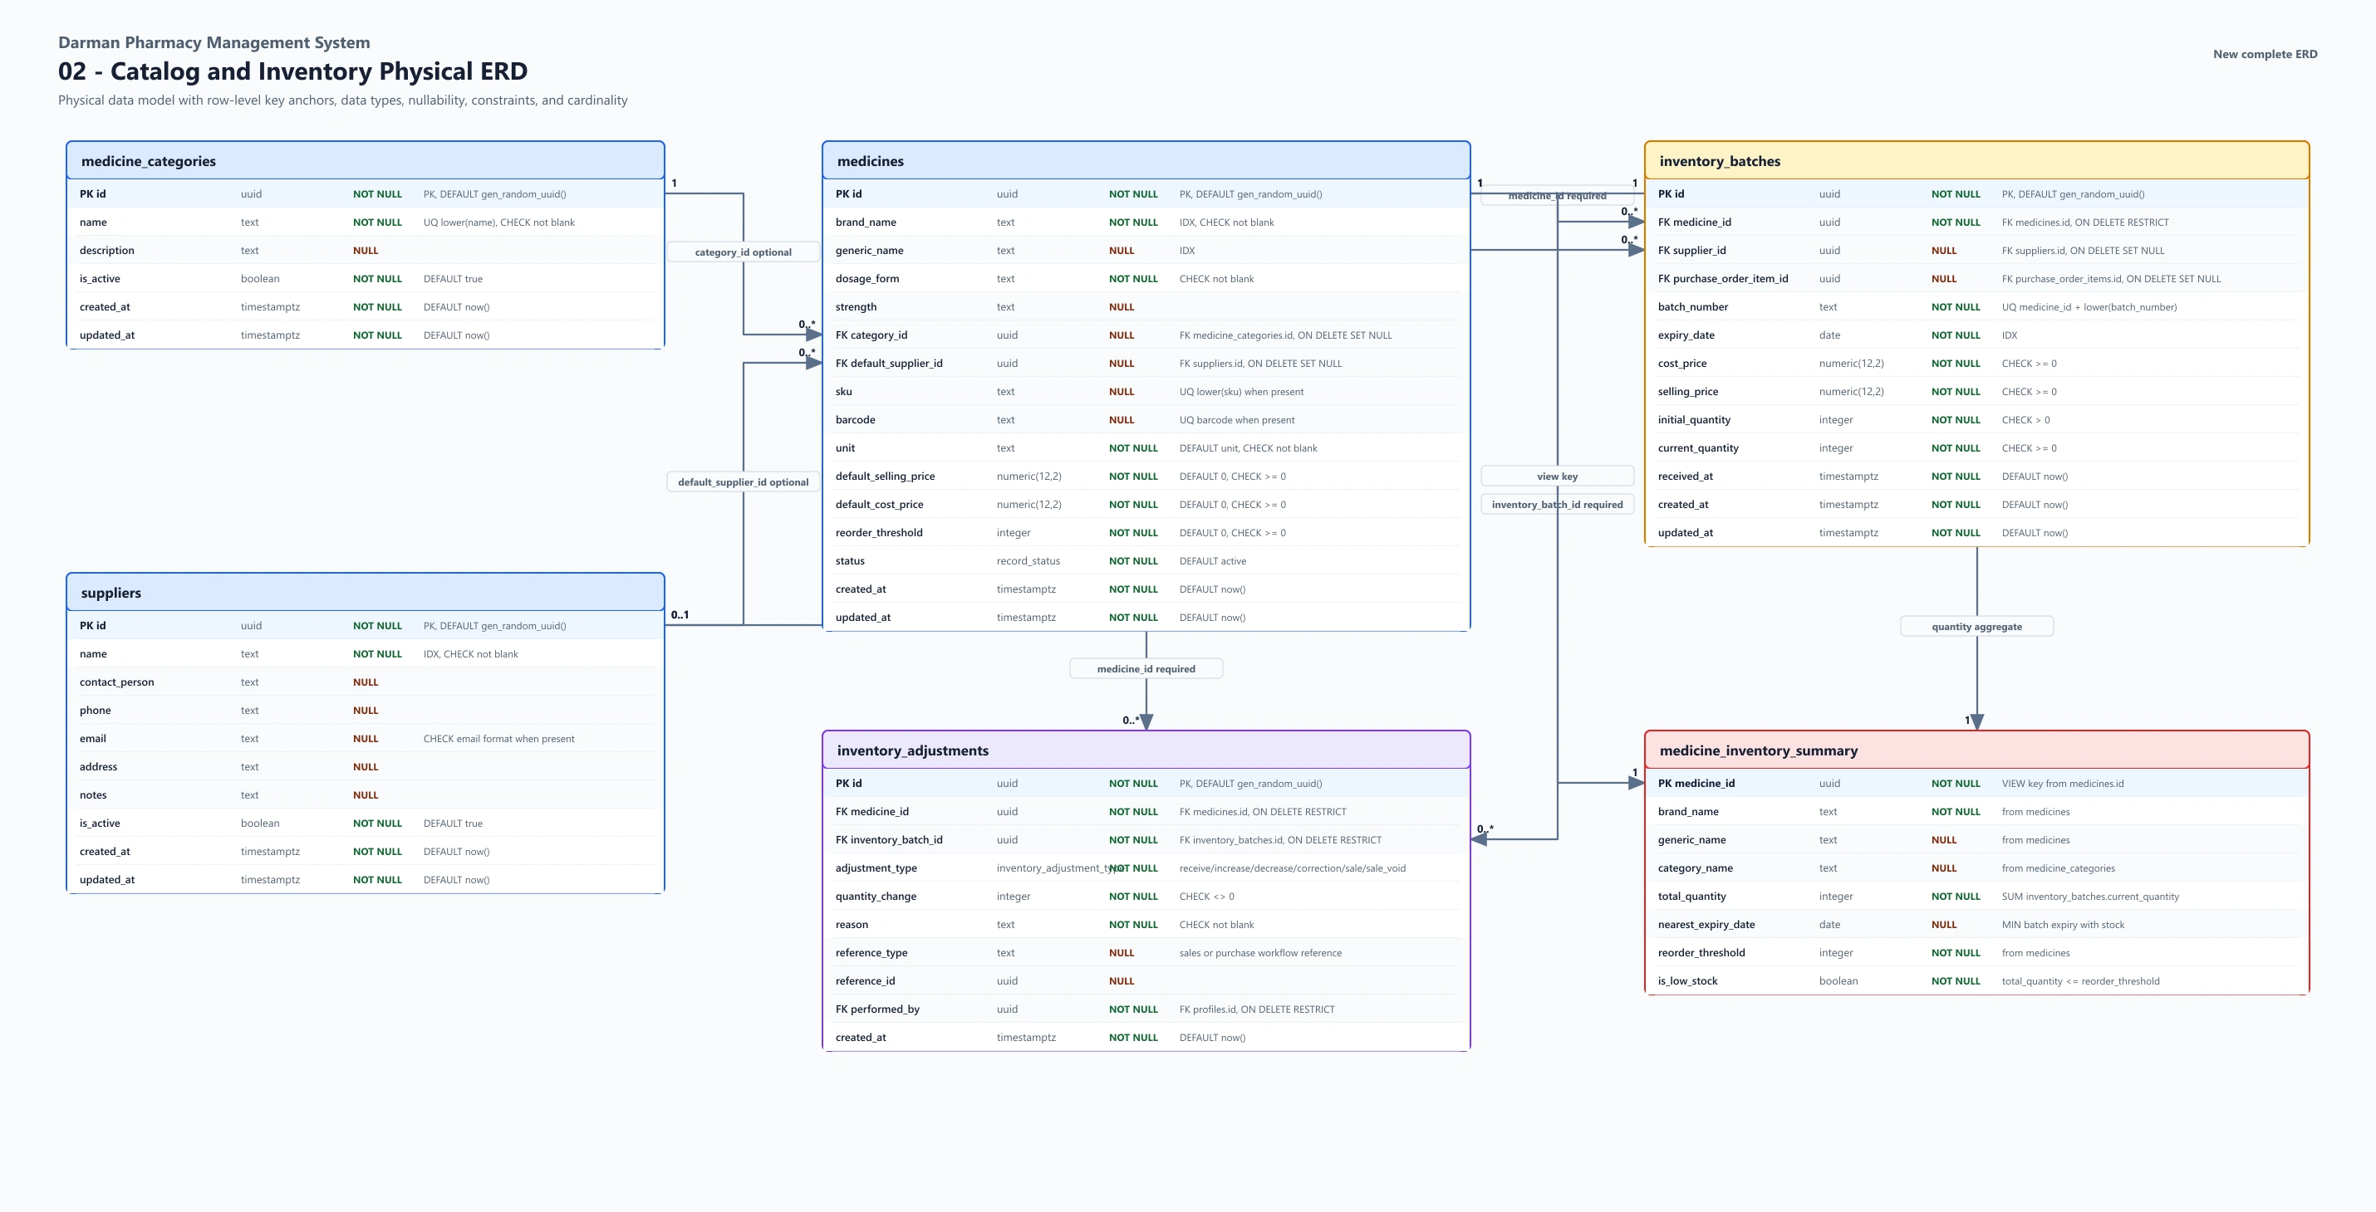
Figure 7. Physical database design for categories, medicines, suppliers, batches, and inventory summary data.

Physical ERD: Sales
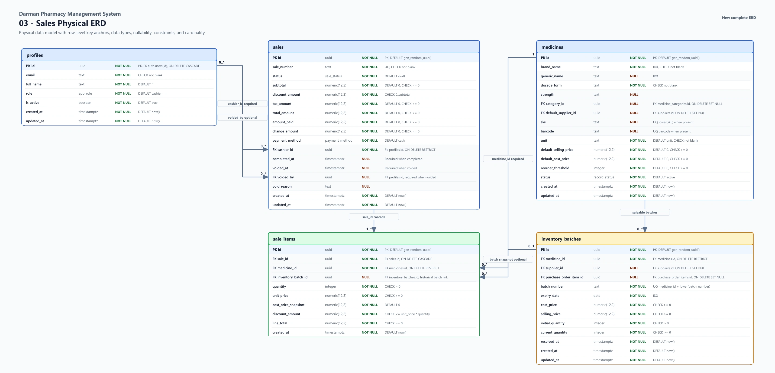
Figure 8. Physical database design for sales and batch-level sale items.

6. Tools and Technologies
The technology selection prioritizes maintainability, type safety, secure managed infrastructure, responsive interfaces, and low initial operating cost.
Area | Tool or Technology | Use in the Project
Application framework | Next.js 16 App Router | Routes, layouts, server rendering, protected navigation, and production builds.
Programming language | TypeScript | Static typing for application, forms, queries, and database-facing code.
User interface | React 19, Tailwind CSS, shadcn/ui, Radix UI | Responsive pages, accessible controls, dialogs, tables, and reusable interface patterns.
Database | Supabase PostgreSQL | Relational schema, constraints, views, transactions, functions, and Row Level Security.
Authentication | Supabase Auth | Email-and-password sessions for controlled staff accounts.
Server state | TanStack Query | Fetching, caching, mutation handling, and targeted refresh after changes.
Forms and validation | React Hook Form and Zod | Validated forms with clear field-level error messages.
Charts | Recharts | Simple dashboard trends and operational visualization.
Document export | jsPDF and CSV generation | Receipts and filtered report downloads.
Diagramming | draw.io | Editable DFD and ERD documentation.
Testing and quality | ESLint, TypeScript compiler, Next.js build, browser and database tests | Code quality, compilation, responsive checks, workflow tests, and release verification.
Hosting | Vercel and Supabase | Managed application, authentication, and database hosting.
Version control | Git | Change tracking, review, release baselines, and rollback support.

7. Project Time and Cost Estimation
SN | Items | Time | Estimate Cost | Purpose
1 | Student development labor | 12 weeks | 0AFN | represents the student's monograph work
2 | Internet and data | 3 months | 2100AFN | Development, research, staging, and deployment access.
3 | Custom domain | 1 year | $20 | Optional professional project address
4
5

Optional Production Costs
SN | Items | Hardware Specifications | Estimate Cost
1 | Vercel | Free tier is suitable for academic demonstration; paid plans depend on production usage. | $50
2 | Supabase | Free tier is suitable for staging; production backup and resource requirements may require a paid plan. | $20
3 | Domain renewal | Recurring annual cost depends on the selected registrar and domain. | $15
4 | Maintenance | Future production support is outside the student's direct project budget. | 100$

8. Project Timeline
The roadmap organizes the project into twelve weekly milestones. Each week produces a defined output that contributes to the final release candidate.
Week | Milestone | Main Activities | Deliverable
1 | Initiation and requirements | Confirm problem, stakeholders, objectives, scope, exclusions, and success criteria. | Approved requirements and scope statement.
2 | Existing-system analysis | Study current workflows, pain points, roles, data, and operational risks. | Problem analysis and process requirements.
3 | Logical and interface design | Prepare DFDs, conceptual ER model, route plan, navigation, and core screens. | Validated logical design and interface direction.
4 | Database foundation | Create tables, relationships, constraints, indexes, profiles, settings, and initial RLS. | Versioned initial migration.
5 | Authentication and roles | Implement sign-in, protected routes, role-aware navigation, and permission handling. | Admin, Pharmacist, and Cashier access.
6 | Medicine and inventory | Build categories, medicine catalog, batch inventory, search, and validation. | Catalog and inventory MVP.
7 | Dashboard and alerts | Implement summary indicators, low-stock warnings, expiry filters, and trend chart. | Operational dashboard.
8 | Sales and POS | Build cashier workflow, barcode input, cart, FEFO sale transaction, history, and receipts. | Protected sales workflow.
9 | Suppliers and purchases | Implement supplier records, purchase orders, statuses, receiving, and stock increases. | Protected purchasing workflow.
10 | Reports and settings | Create reports, exports, search controls, pharmacy settings, and user-role management. | Operational reporting and administration.
11 | Hardening and QA | Run lint, type checks, builds, role tests, RLS tests, concurrency, rollback, responsive, and export tests. | Release candidate and QA evidence.
12 | Deployment and documentation | Deploy staging, prepare production steps, complete user guide, proposal, and presentation evidence. | Staging release and final documentation.

9. Risk Assessment and Trust Signals

9.1 Risk Assessment
Risk | Impact | Likelihood | Mitigation | Residual Risk
Unauthorized data access | High | Medium | Role-aware routes, RLS on all application tables, database role checks, disabled public signup, and denial tests. | Low
Incorrect stock after concurrent sales | High | Medium | Transactional sale function, batch locking, FEFO allocation, trusted recalculation, and concurrency tests. | Low
Partial purchase receiving | High | Medium | Atomic receiving function, order locking, duplicate-batch checks, rollback tests, and duplicate-delivery protection. | Low
Expired stock sold | High | Low | Expiry-aware saleable stock, FEFO ordering, expiry validation, and dashboard warnings. | Low
User adoption difficulty | Medium | Medium | Beginner-focused interface, limited role menus, clear messages, responsive layouts, and client guide. | Low
Cloud service or internet interruption | Medium | Medium | Managed hosting, documented ownership, status monitoring, and operational communication. Offline mode is outside MVP scope. | Medium
Backup ownership not assigned | High | Medium | Production launch gate requires named ownership, selected Supabase backup policy, and recovery verification. | Medium until completed
Production configuration error | High | Medium | Ordered migrations, documented environment values, Auth URL checklist, staging baseline, and production smoke tests. | Low after deployment checks
Schedule pressure | Medium | Medium | Twelve-week milestones, explicit exclusions, modular delivery, and priority on release-critical workflows. | Low
Future data growth | Medium | Low | Indexes, pagination, filtered views, and a documented path toward database reporting functions if scale requires them. | Low

10. Conclusion
Darman Pharmacy Management System is a focused response to the operational needs of a single community pharmacy. Its design connects medicine records, batch inventory, purchasing, sales, alerts, users, and reports in one controlled system. The scope remains practical by excluding clinical records, prescriptions, insurance, multi-branch management, accounting, and automation features that would weaken the clarity of the first release.
The project demonstrates a complete academic and professional software process: problem analysis, scope control, logical modeling, relational database design, role-based security, transactional workflows, responsive interface design, testing, deployment planning, and user documentation. Staging evidence shows that the release candidate performs its critical workflows correctly. Completion of the stated production setup and backup tasks will prepare the system for controlled real-world use.

11. References
- Darman project source of truth. PROJECT_STATE.md, repository state dated June 23, 2026.
- Darman deployment guide. docs/DEPLOYMENT.md.
- Darman client user manual. docs/CLIENT_GUIDE.md.
- Darman staging QA results. docs/STAGING_QA_RESULTS.md, June 19, 2026.
- Supabase documentation. https://supabase.com/docs
- Next.js documentation. https://nextjs.org/docs
- Vercel documentation. https://vercel.com/docs
- PostgreSQL documentation. https://www.postgresql.org/docs/
- OWASP. OWASP Application Security Verification Standard and web security guidance, https://owasp.org/

PROJECT PROPOSAL APPROVAL SHEET

The undersigned certify that they have read the following Project Proposal and are satisfied with the overall contents and idea, and recommend the project proposal to the faculty of Computer Science for acceptance.

Title: Your Project Title
Prepared by: Your Name

Recommended by: Mr. Sayed Hassan Sabit
Vice Dean & Coordinator

Project Coordinator: Mr. Sayed Hassan Sabit

Dean of BCS Faculty: Mr. Abdul Ghafar Omarkhel

